Faculty Achievement: NPTEL Discipline Star in Computer Science and Engineering

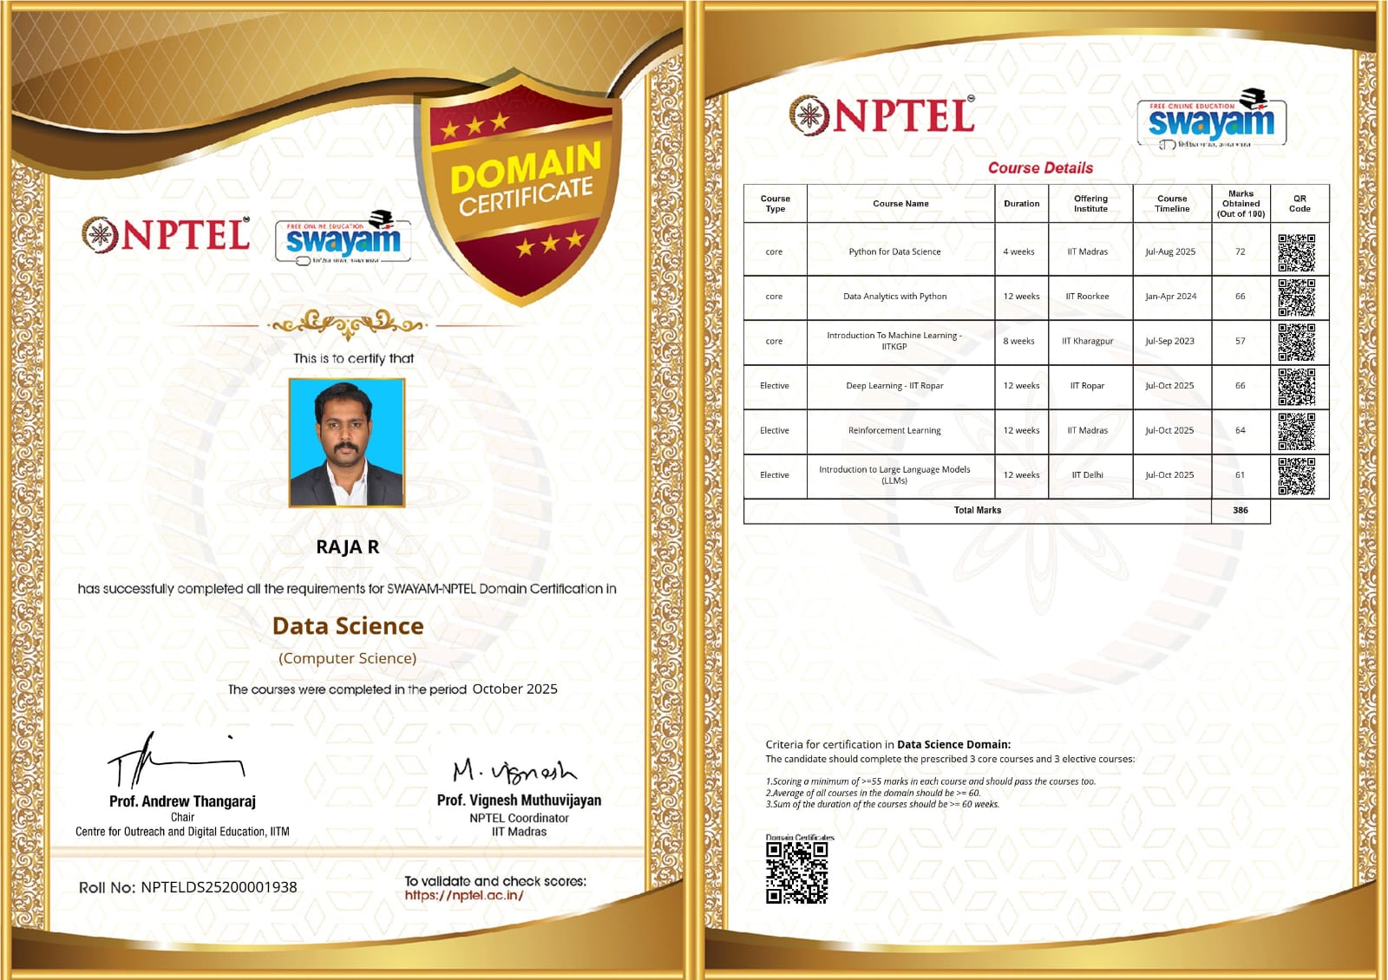

1. NPTEL Data Science Domain Certification

Faculty Achievement – SWAYAM NPTEL Data Science Domain Certification
The Department of Computer Science and Engineering proudly congratulates Mr. Raja R for earning the prestigious SWAYAM–NPTEL Data Science Domain Certification (Computer Science) awarded by NPTEL, IIT Madras. This national-level certification recognizes learners who successfully complete a carefully curated set of core and elective courses in the field of Data Science while meeting stringent academic performance criteria.
To achieve this certification, Mr. Raja R successfully completed six NPTEL courses covering Python for Data Science, Data Analytics with Python, Introduction to Machine Learning, Deep Learning, Reinforcement Learning, and Introduction to Large Language Models (LLMs) offered by premier IITs, including IIT Madras, IIT Roorkee, IIT Kharagpur, IIT Ropar, and IIT Delhi. The combined duration of these courses exceeded 60 weeks of rigorous learning, and he secured a total aggregate score of 386 marks.
The Data Science Domain Certification was awarded in October 2025, reflecting his commitment to continuous learning and excellence in emerging technologies. This remarkable accomplishment demonstrates his expertise in Artificial Intelligence, Machine Learning, Data Science, and advanced computing, while contributing to quality teaching, research, and innovation within the institution.
The Management, Principal, and the Department of Computer Science and Engineering extend their heartfelt congratulations to Mr. Raja R on this outstanding national-level achievement and wish him continued success in all his future academic and professional endeavors.
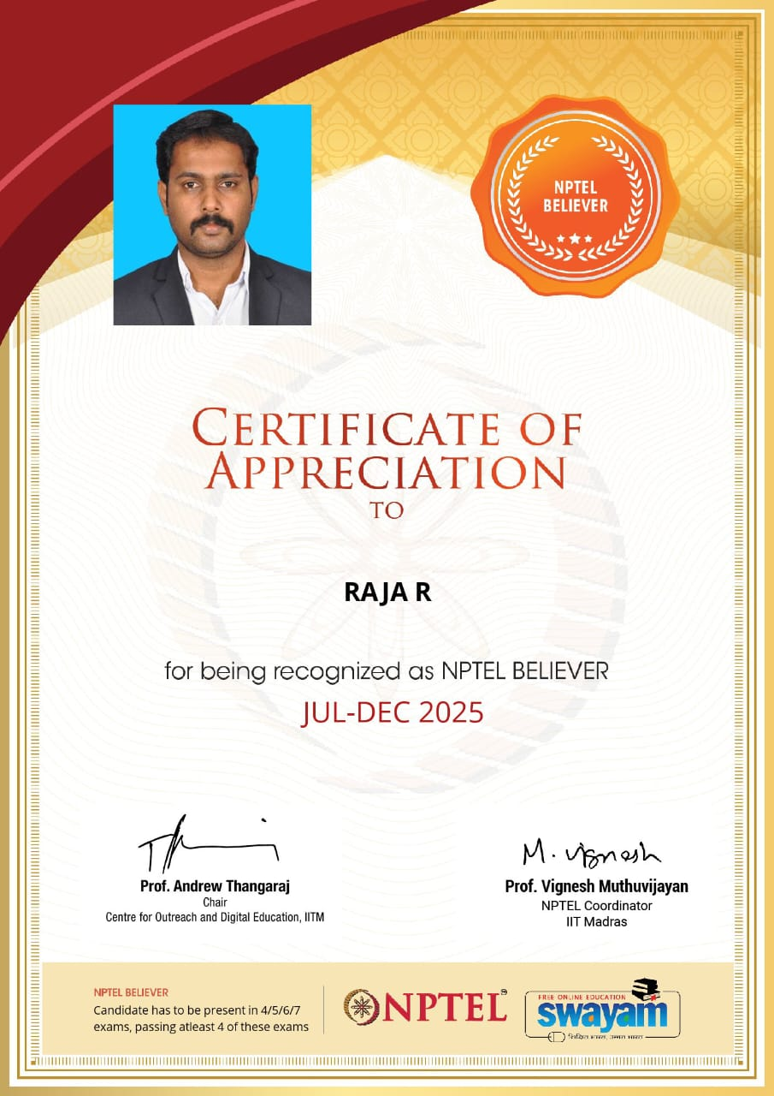

2. NPTEL Believer Recognition

Faculty Achievement – NPTEL Believer Recognition (Jul–Dec 2025)
The Department of Computer Science and Engineering is delighted to congratulate Mr. Raja R on receiving the prestigious NPTEL Believer Recognition for the July–December 2025 semester.
The NPTEL Believer title is awarded by NPTEL, IIT Madras to learners who demonstrate exceptional dedication towards online education by registering for multiple NPTEL certification examinations and successfully passing at least four certified courses within a single semester. The recognition reflects consistency, perseverance, and an unwavering commitment to academic excellence.
Receiving this honor signifies Mr. Raja R's passion for lifelong learning and his continuous efforts to upgrade his knowledge in cutting-edge technologies. His dedication to professional development serves as an inspiration to students and fellow faculty members alike, encouraging a culture of continuous learning and innovation.
The Management, Principal, and the Department of Computer Science and Engineering congratulate Mr. Raja R on this noteworthy accomplishment and wish him many more successes in his academic and professional journey.

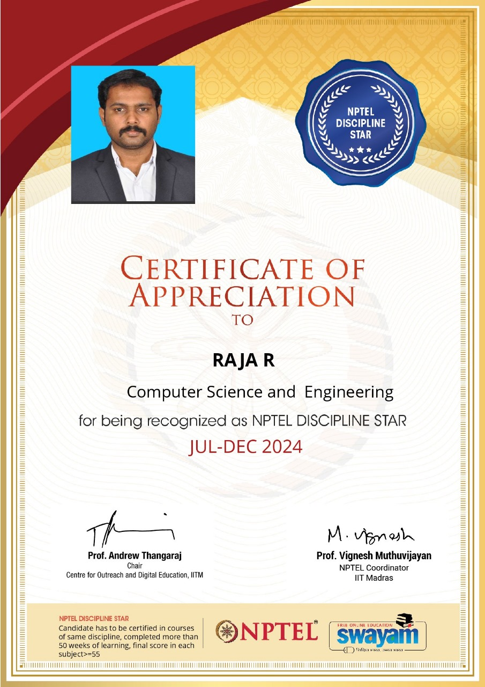

3. NPTEL Discipline Star Recognition

Faculty Achievement – NPTEL Discipline Star in Computer Science and Engineering
The Department of Computer Science and Engineering proudly congratulates Mr. Raja R on being recognized as an NPTEL Discipline Star in Computer Science and Engineering for the July–December 2024 semester by NPTEL, IIT Madras.
The NPTEL Discipline Star recognition is awarded to learners who successfully complete more than 50 weeks of certified courses within the same discipline while securing a minimum score of 55% in every course. This recognition highlights consistent academic excellence and in-depth knowledge in a specialized field.
Through his dedicated efforts and outstanding academic performance, Mr. Raja R fulfilled all the eligibility criteria and earned this prestigious national recognition. The award reflects his strong foundation in Computer Science, commitment to professional growth, and enthusiasm for acquiring advanced technical knowledge through continuous learning.
This achievement reinforces the institution's commitment to promoting excellence in teaching, research, and skill development. It also motivates students to actively participate in nationally recognized certification programs that enhance both academic knowledge and industry readiness.
The Management, Principal, and the Department of Computer Science and Engineering extend their sincere congratulations to Mr. Raja R on receiving this distinguished recognition and wish him continued success in his future endeavors.
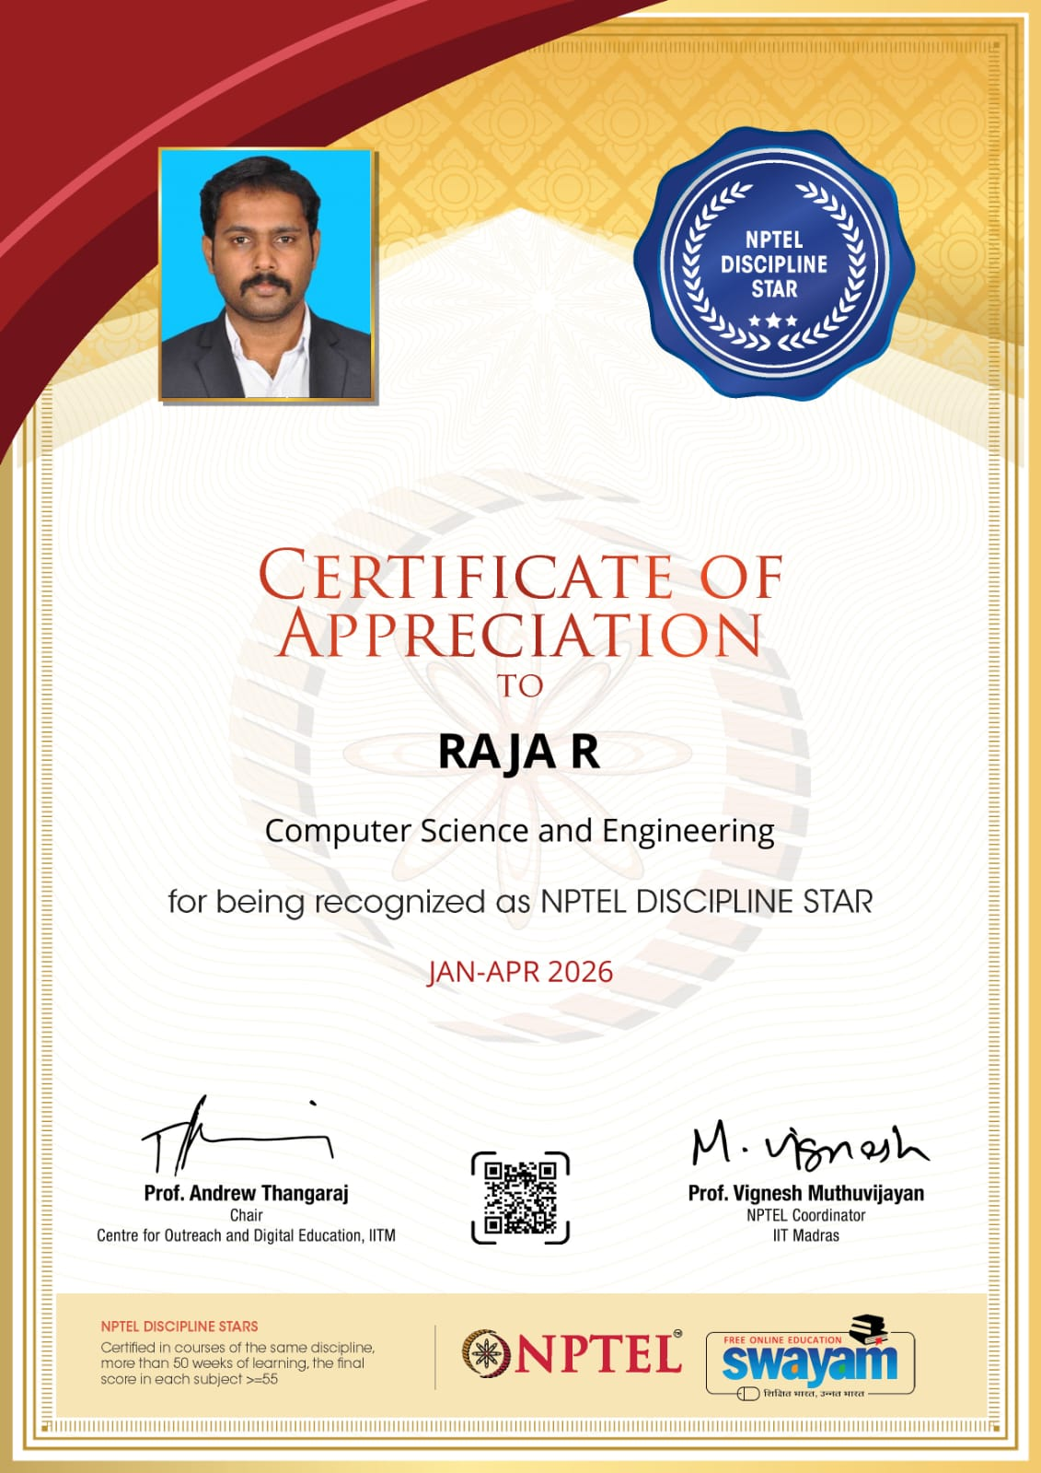

4.Faculty Achievement – NPTEL Discipline Star in Computer Science and Engineering (January–April 2026)
The Department of Computer Science and Engineering proudly congratulates Mr. Raja R on being recognized as an NPTEL Discipline Star in Computer Science and Engineering for the January–April 2026 semester by NPTEL, IIT Madras.
The NPTEL Discipline Star recognition is conferred upon learners who successfully complete more than 50 weeks of certified courses within the same discipline while securing a minimum score of 55% in every course. This prestigious national-level recognition acknowledges consistent academic excellence, subject expertise, and an unwavering commitment to continuous learning.
Through his dedicated efforts and outstanding academic performance, Mr. Raja R fulfilled all the eligibility criteria and earned this distinguished recognition for the second consecutive time. This achievement reflects his strong foundation in Computer Science and Engineering, commitment to professional development, and continuous pursuit of knowledge in emerging technologies through the SWAYAM–NPTEL platform.
Receiving the NPTEL Discipline Star recognition once again demonstrates his dedication to academic excellence and reinforces the institution's vision of promoting quality education, research, and lifelong learning. His accomplishment serves as an inspiration to students and fellow faculty members to actively engage in nationally recognized certification programs that enhance technical competence and industry readiness.
The Management, Principal, and the Department of Computer Science and Engineering extend their heartfelt congratulations to Mr. Raja R on receiving this prestigious national recognition and wish him continued success in all his future academic and professional endeavors.

